All the below approximations were obtained by minimizing the infinity norm.

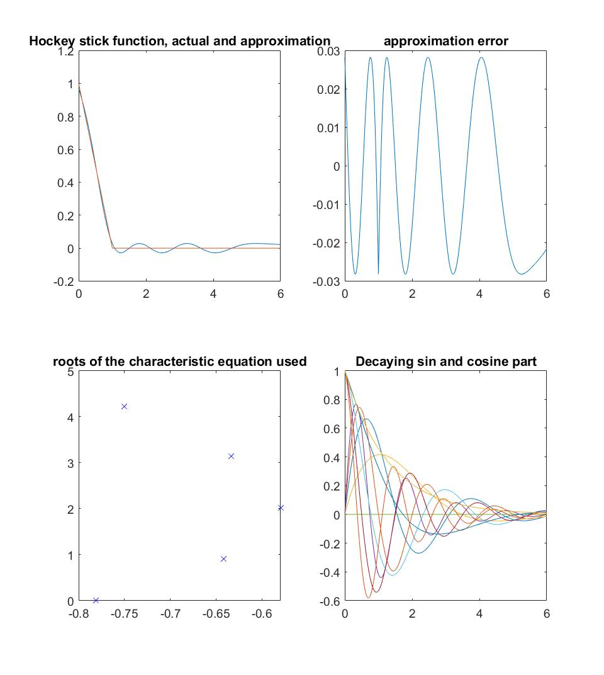

Figure 1. Approximation obtained using (5x2 roots)

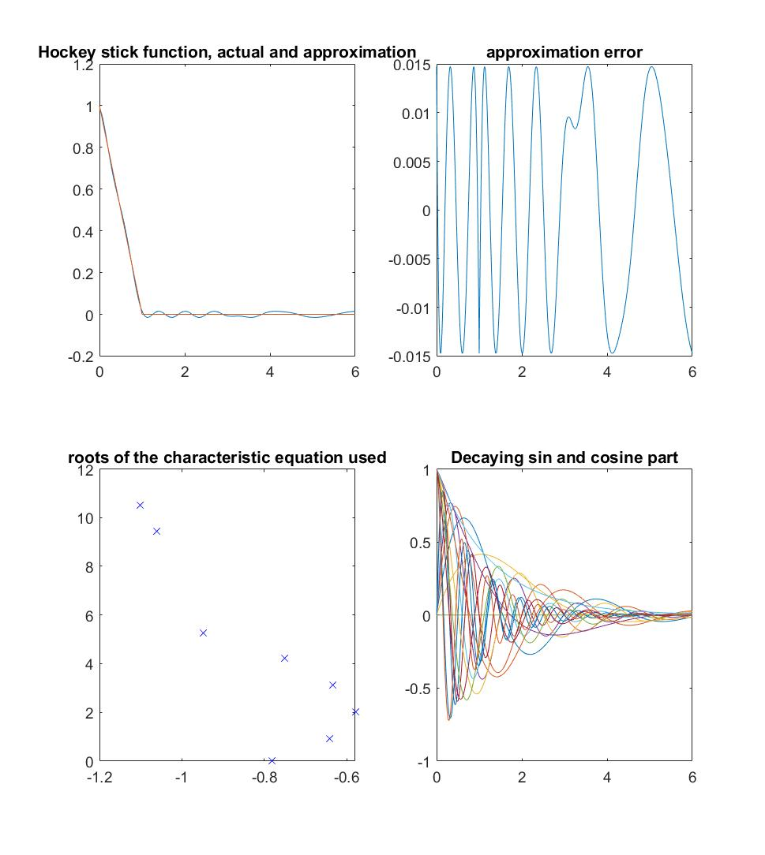

Figure 2. Approximation obtained using (8x2 roots)

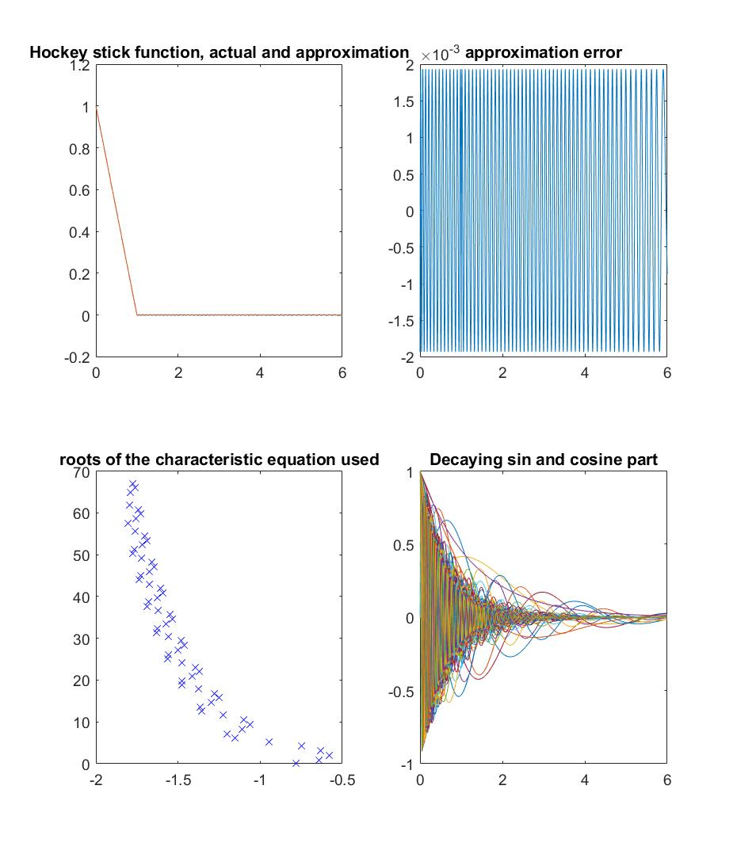

Figure 3. Approximation obtained using (62x2 roots)

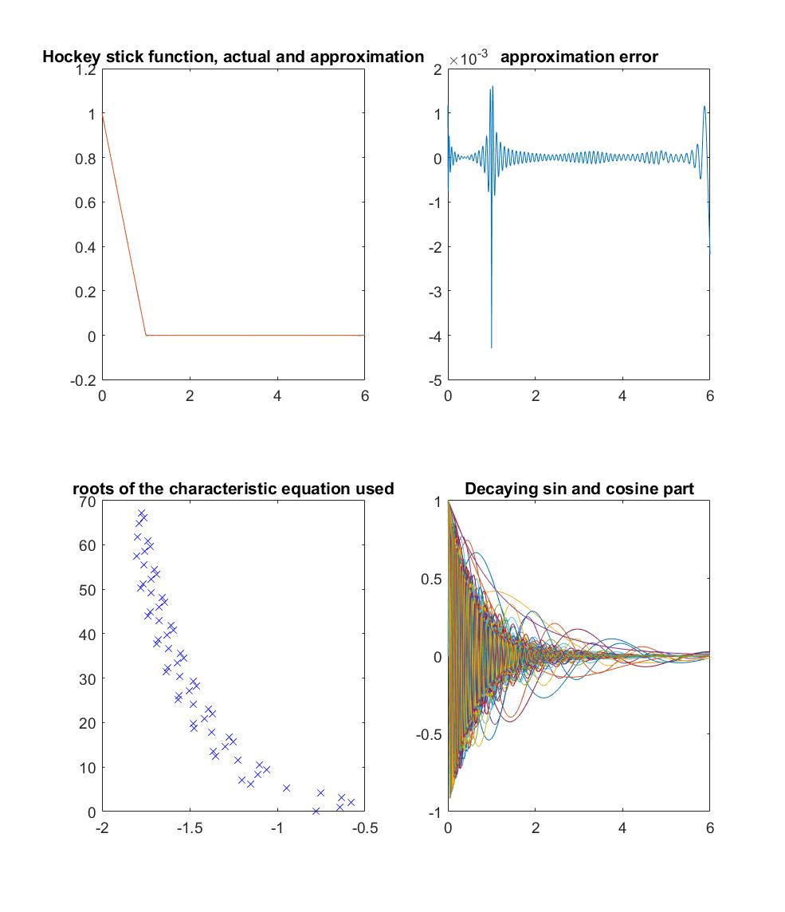

Figure 4. Approximation obtained using (62x2 roots) and least squares